PTSS2003 915 MHz Band Transceiver – Data Sheet

- FCC Modular Certification ID: QLBPTSS2003
Features
- XEMICS XE1202 Transceiver
- Customizable TI MSP430 Microcontroller
- RFMD Power Amplifier
- Asynchronous Serial Interface
- Frequency Hopping Spread Spectrum over 160 Channels Ranging From 902 to 928 MHz
- User Selectable Hop Table (65536 Tables)
- Low Power Consumption
- Shut Down mode, < 10uA
- High receiver sensitivity, -107dBm
- SAW filter for high interference rejection.
- 250 mW Transmit Power
- Small Form Factor (1.7” x 1.5” x .35”)
- CRC-16 Error Detection with User Selectable Auto Resend on Error
- User Selectable Data Encryption
- 76,800 bits/sec Data Rate
- 200KHz receive bandwidth

The PTSS2003 is a compact, ready-to-use, FCC-certified Frequency Hopping Spread Spectrum transceiver that operates in the
Product Overview
license-free 902 – 928 MHz band. It is ideal for OEM applications that require a wireless data connection, and it can also be easily integrated into existing systems. This versatile module will simplify the task of using wireless to send/receive data, using the latest RFIC technology and a customizable TI MSP430 microcontroller.
- Remote Sensor Monitoring
- Home Automation
- Remote Keyless Entry
- Remote Control
- Security Devices
- Power Sensitive Wireless Applications

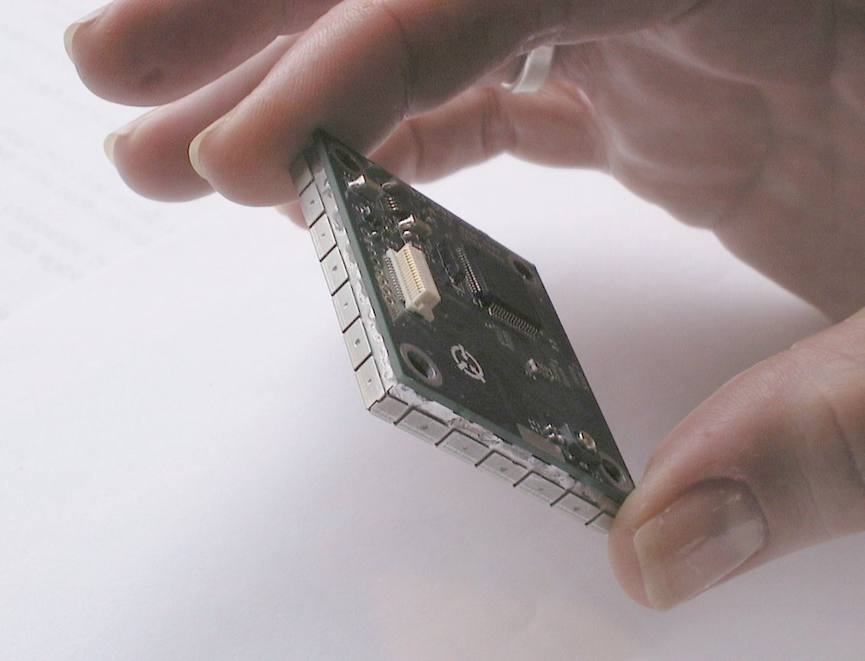

The PTSS2003 is only 1.5” x 1.7” x .35”

Applications
The PTSS2003 can work in systems with or without an external processor. When there is no host for the system or for specialized applications, Pegasus can easily customize the microcontroller firmware to meet your needs.
Low operating power requirements and very low power consumption in shut down mode make this the ideal module for applications where long battery life is important.

Electrical Specifications
 | Min | Typical | Max | Units
Power Supply Voltage | 2.9 | 3.3 | 5.5 | Volts
Power Supply Current
Sleep Mode (27 C) |  | 6 | 20 | uA
Receive Mode |  | 30 | 60 | mA
Transmit Mode |  | 400 | 500 | mA
Serial Host Interface
‘0’ Voltage Level | 0 |  | 0.6 |  | V
‘1’ Voltage Level | 2.4 |  | 3.5 |  | V
Host Data Rate | 9600 |  | 115200 |  | bps
Analog Channels
Channels |  | 2 |  |  |  | channels
Input Range | 0 |  | 2.5 |  |  | Volts
Quantization |  | 12 |  |  |  | Bits
RF Specifications
Frequency Range | 902 |  | 928 |  |  | MHz
Frequency Stability |  | 20 |  |  |  | ppm
Architecture | Frequency Hopping Spread Spectrum
Channels per hop table | 50 |  |  |  |  | channels
Available channels |  | 48000 |  |  |  | channels
Packet Length | 8 |  | 760 |  |  | bits
Receiver Sensitivity |  | -107 |  |  |  | dBm
Out of Band Rejection |  | 40 |  |  |  | dB
Transmitter
RF Output Power |  | 250 |  |  |  | mW
Modulation |  | 2-FSK
Data Rate |  | 76800 |  |  |  | bps
Deviation |  | ±100 |  |  |  | KHz

Environmental Conditions
Operating Temperature | -40 C to + 80 C
Relative Humidity | 5% to 95% Non Condensing

Mechanical Dimensions
Length | 1.70 ± 0.01 | inch
Width | 1.50 ± 0.01 | inch
Height | 0.35 ± 0.02 | inch

